**Fresh install of django in virtual env**

Mkdir djangoProject

Cd djangoProject

Pip install virtual env

Virtualenv env

env\Scripts\activate

Pip install django

Django-admin

Python mange.py runserver

Python –m django --version

**First activate the virtual env then run mange.py**

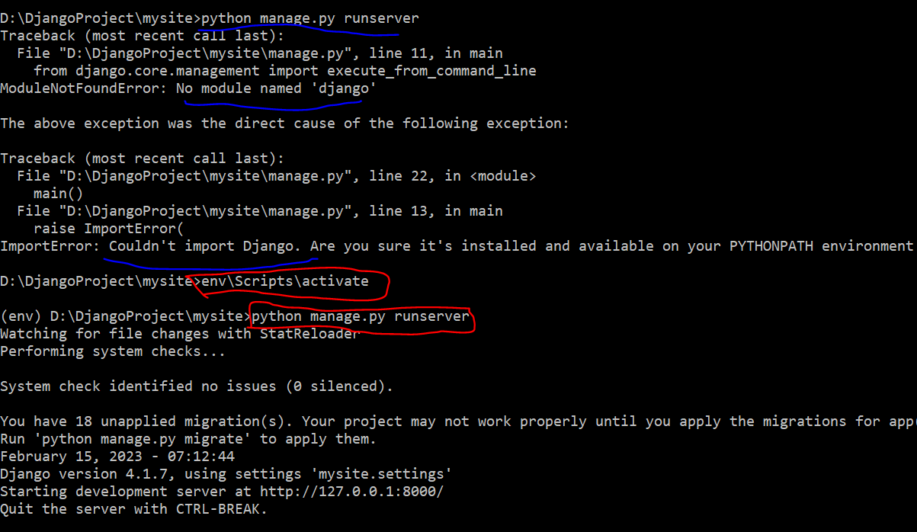

Complete guideline to install django

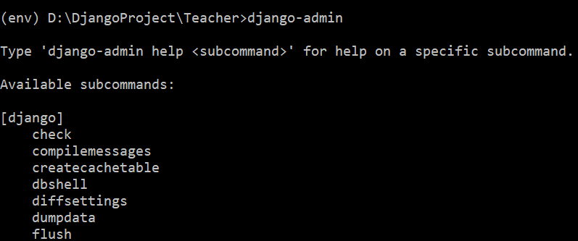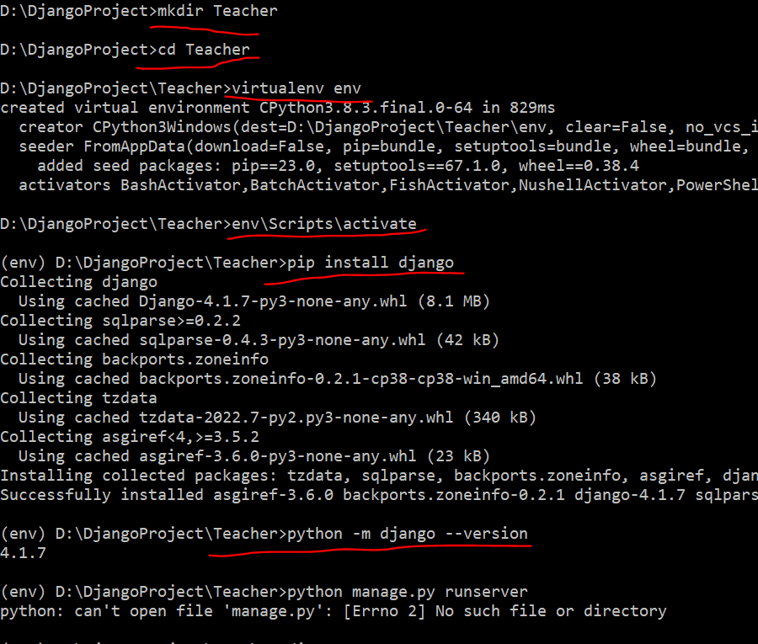



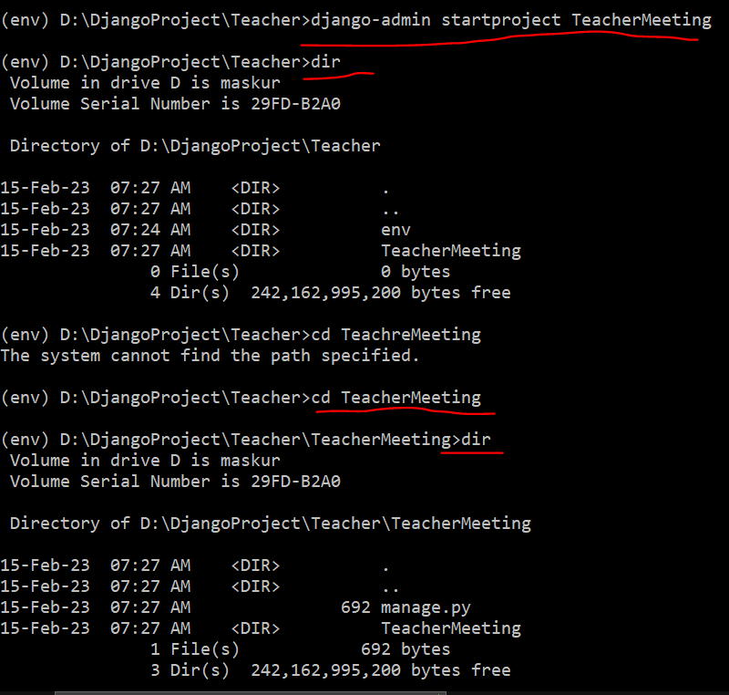

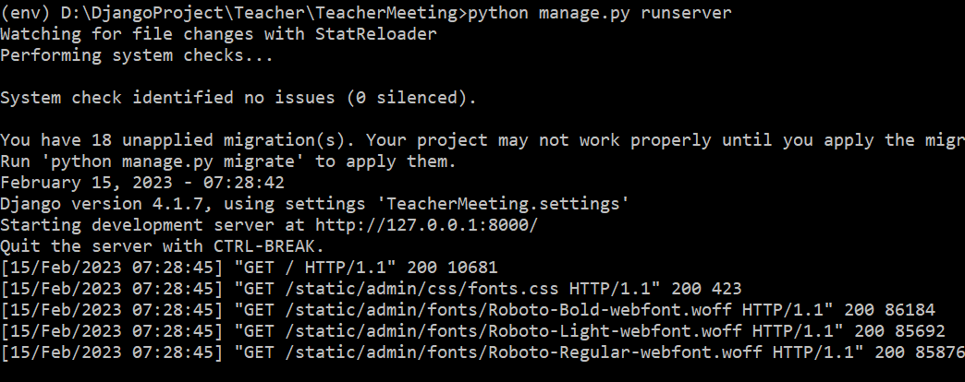

Now you can go to browser : 127.0.0.1:8000

After closing this terminal and again to start server go to the Teacher folder and activate the env by (env\Scripts\activate)

